Project Report

# Client Name: Big Mountain Resorts

# Client Background:

Big Mountain Resort is located in north-western Montana. Big Mountain Resort offers spectacular views of Glacier National Park and Flathead National Forest. The resort originally opened in 1947 with an annual snowfall of 333 inches and 3,000 acres of skier and rider accessible terrain. Big Mountain Resort offers access to 105 named trails and vast bowl and tree skiing.

# Client Requirement:

Recently, Big Mountain Resort installed a new chair lift. This additional chair increases their operating costs by $1,540,000 this season. The client is looking forward towards our recommendation for keeping the prices sustainable and competitive.

# Data Source:

We have a dataset, of 330 resorts in the US that can be considered part of the same market.

# Recommended Value:

Based on the competition’s prices, recommend a value for an Adult over the weekend should be $75.67/-. With a margin of $7.62/-.

# Observations:

Based on p-value analysis, we can conclude that some features can really impact weekend prices such as: SkiableTerrain_ac, TerrainParks, and chairs especially – quad, triple and double.

# Visualisation:

1. Based on ‘Summit Elevation’ and ‘Vertical Drop’, Resorts can be divided into 2 clusters. ‘+’ indicates Big Mountain Resorts. This resort is in cluster 2.

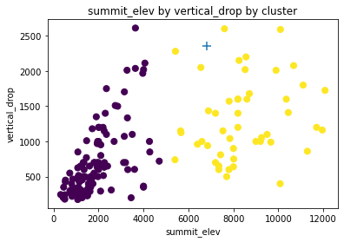

1. Comparison of Actual Prices vs Predicted Prices, RMSE of around 7.62.

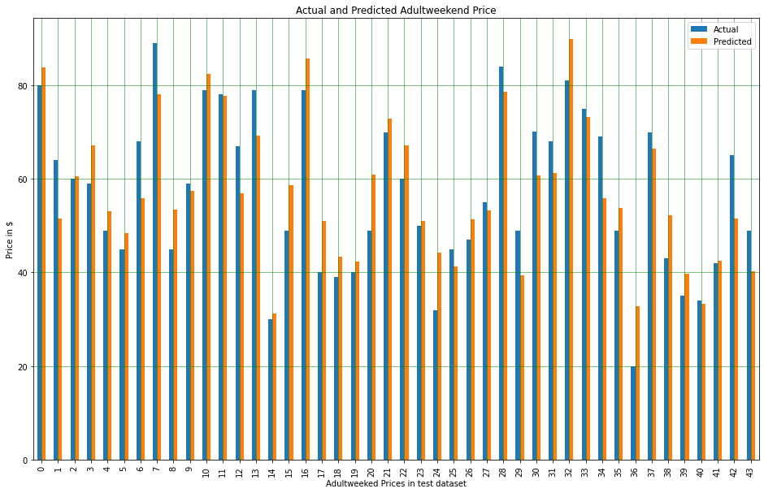

1. The predicted values are well within the expected range.

